[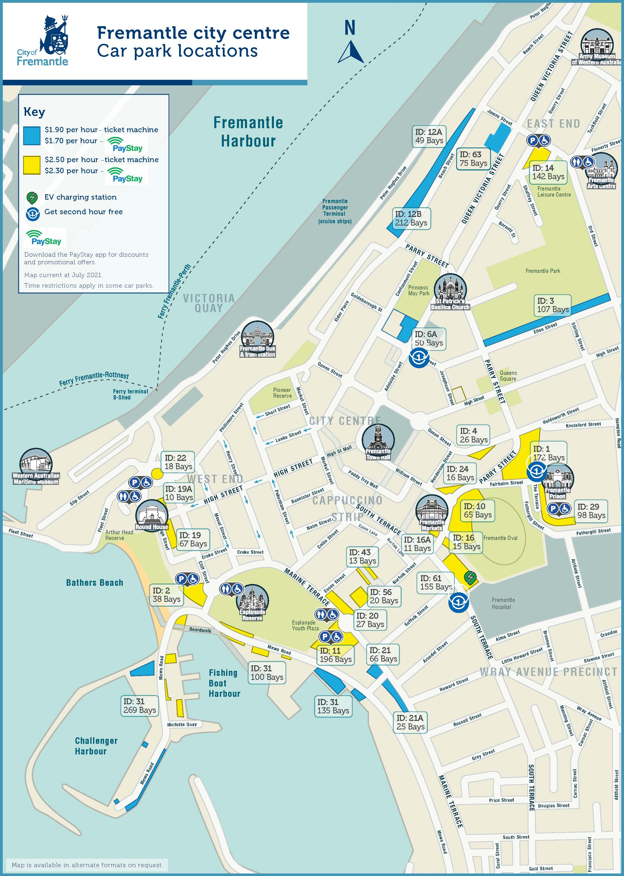](https://www.fremantle.wa.gov.au/sites/default/files/FRE556%20CoF_CarParks-July%202021.pdf)